In this project I will be recreating the FSTP (Field Services Technician Passport) application in sandbox environment to allow for a more better supported, controlled, and repeatable learning experience. As of now there is not an opportunity for new or struggling technicians to gain exposure to the app except with a live work order and second-hand knowledge from another field employee. This unregulated information and limiting exposure contributes to negative impacts in both high value metrics and job satisfaction.

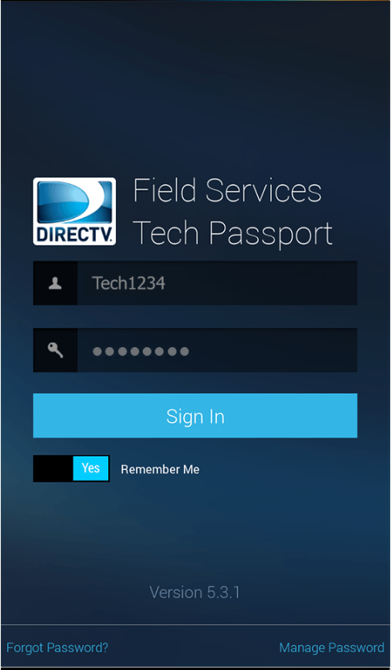

The initial build will include a login screen as the landing page for real feel and familiarity.

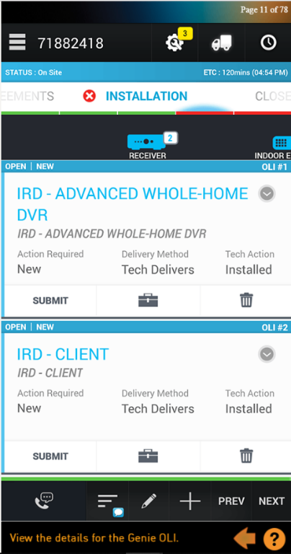

In the first version the user will be taken directly into a work order after login with preceding customer interactions to be added later.

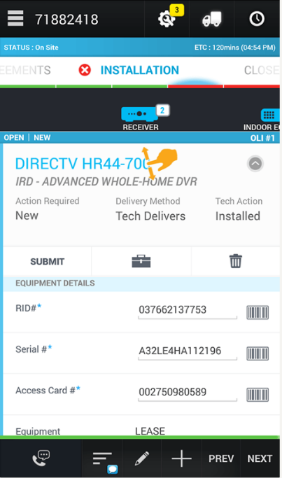

User will have the ability to interact with a line item and be required to submit the proper information in the correct locations on submission. Correct submissions will in a success confirmation.

This opportunity the learning environment provides will dramatically impact operational standards such as customer service ratings, safety risks due to longer working hours, overtime pay, employee retention, scheduled work order completion rated which all will lead to greater profitability.